

COMM2312: Technical and Professional Communication, Section#

Submitted to Dr Joel Richmond

Assignment 3: Technical Manual

Date: 5/11/2025

Table of Contents
1.0 Introduction 3
1.1 Definition and History 3
1.2 Benefits 3
1.3 Purpose of Instructions 4
2.0 Operating Instructions 4
2.1 First Major Step: 4
2.2 Second Major Step: open and use application 5
2.3 Third Major Step: Adjust settings to use AI tools 5
2.4 Fourth Major Step: Checking the security system 6
2.5 Fifth Major Step: Ch cking software updates 7
3.0 Conclusion 7
3.1 Revising the major steps performance 8
3.2 Glossary 9

1.0 Introduction

1.1 Definition and History
The Apple Mac Pro 14-inch M5 is the final version, which was produced in 2025. This professional laptop is useful for developers, video editors, designers, and others. The Apple company updated this final version to be suitable for the artificial intelligence tools. Also, the producer of this device is focusing on enhancing the graphic tools' performance. The laptop has a long battery life and allows users to analyze the current and historical data to make good decisions. The man who created this laptop needs to help users use the AI tools professionally and to create attractive designs. Moreover, the modern version improved Apple's intelligence features for architects, UX designers, logo designers, and photographers.



1.2 Benefits
The Apple Mac Pro 14-inch has several benefits, such as:
- Good Battery life: This laptop is suitable for individuals who need a device that lasts all day.
- Productive for professional users: This device is perfect for programmers, photographers, and designers.
- High quality of the Camera: Apple Mac Pro 14-inch M5 allows students and designers to see clear images and videos.

1.3 Purpose of Instructions
The purpose of this professional device is to support employers, students, and others in designing a professional design and to guide users how to use the Apple Mac Pro 14-inch M5. The manual should be analyzed properly. Furthermore, if the users do not read the guidelines of the manual properly, they will damage the device.

2.0 Operating Instructions

2.1 First Major Step: Please read the device’s instructions, then press the button to turn on the Apple Mac Pro 14-inch M5 Laptop.
2.1.1 Please check the unboxing of the device to use the important items such as:
- USB-C
- USB-C power adapter
- Apple stickers



2.2 Second Major Step: Open and use the Application
2.2.1 Please enter your ID and password to save your personal information: Your Apple email account will recover your personal data from hacking or losing your professional device.

2.2.2 Connect the Wi-Fi to your Apple: Connecting the Wi-Fi to the laptop will encourage creative people to understand the modern AI tools and the laptop’s features. The laptop’s features are relevant for photographers and video editors to present their work productively and professionally.

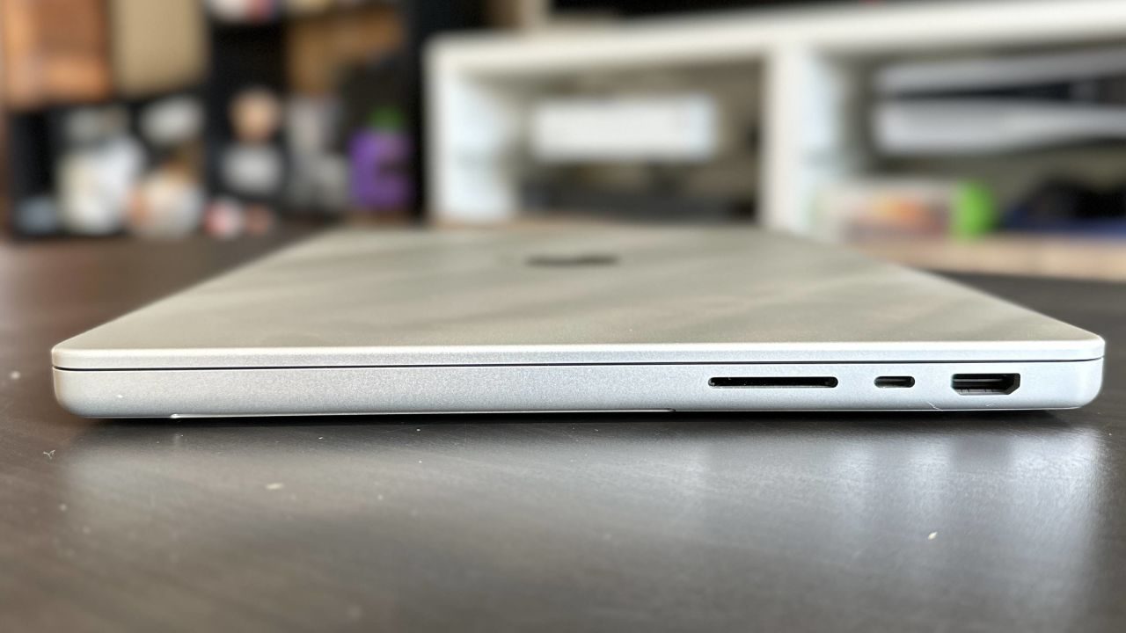

2.3 Third Major Step: Use creative AI tools
2.3. The AI tools allow photographers and video editors to create an advanced design, as the advanced design motivates the designer to save their time and effort. The Apple silicon is a tool that boosts the performance of voice recognition, Photoshop, and video editing.

Notes:
The individuals need to enhance their AI skills to use the Apple Mac Pro 14-inch M5 in an effective way.
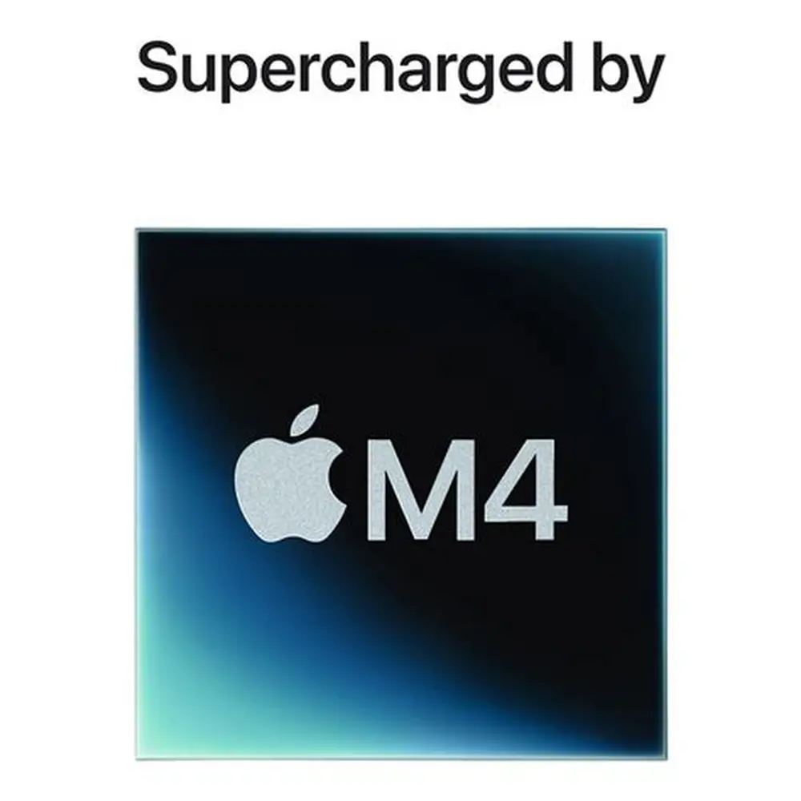

2.4 Fourth Major Step: Security tools: The security tools enable the users to protect and recover the laptop's files, and the users can download an application called Malware to recover their devices from any threats.

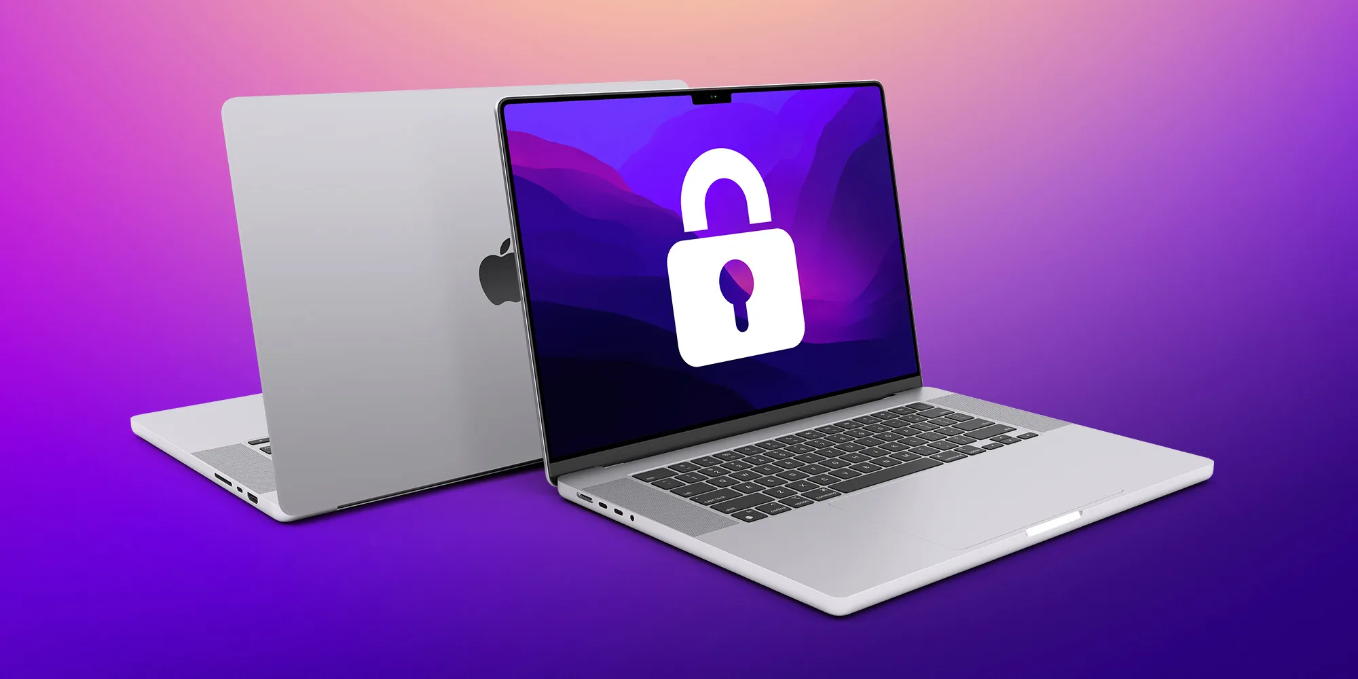

2.5 Fifth Major Step: Software Update Tools :
2.5 Checking the Laptop updates: Checking the laptop updates will lead the workers to advance their work.
The new updates will improve the system of the device and will enable the users to decrease drug issues and increase tracking speed.

Warnings:
- Protect the battery health of the device and connect the device to the charger if it is low.
- Please delete unimportant folders to save the laptop's life from being damaged.
Cautions:
- Overcoming the high temperature
- Back up the data and the information regularly
- Decreasing the overloading system.
Danger:
- Overheating
- Power problems
- Putting liquid drinks next to the device.

Instructions for troubleshooting
- Issue: Do not put liquid objects near the item
  - Cause: The liquid object will damage the laptop
  - Solution: Keep the device off and disconnect the charger.

- Issue: Move the device from soft objects , such as the sofa and bed.
  - Cause : It damages the battery performance and overheats the device
  - Solution: Remove the device from the soft objects.

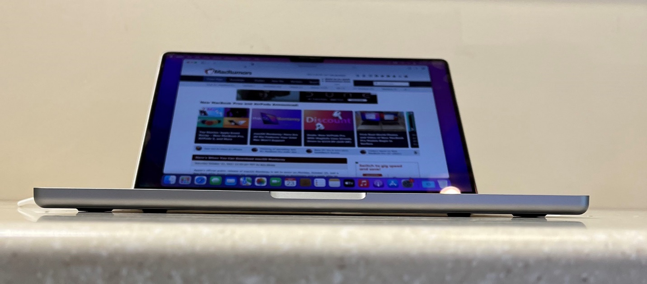

3.0 Conclusion
3.1 Revising the major steps:

The artificial intelligence tools enhance the performance and the services of the Apple Mac Pro 14-inch. The laptop manages the consumer's time and inspires them to create unique projects and tasks. In addition, the software system and the laptop systems in general are enthusiastic for the users because they support them to learn about the importance of AI, Lightroom, graphic designs, and Photoshop. Finally, professional users must be aware of the laptop damage, warnings to save the device's life.

3.2 Glossary
- Voice recognition is a modern technology tool that allows us to interpret the computer’s data into spoken words.
- Malware: is a modern software application that is designed to attack the personal accounts of users.
- Apple silicon: The system that is designed for Apple users and includes several components, such as CPU and GPU, to improve the productivity of the device.
- Overloading system: this occurs when the hardware and software of the device slow down its performance.
- Cautions: is a term that informs the users to protect the device from any dangers.

